Refer the following table employee and identify the correct, “Create Table” Statement for this table.

**Employee:**

|  |  |  |  |
| --- | --- | --- | --- |
| **ID** | **LASTNAME** | **FIRSTNAME** | **AGE** |
| **19** | **Rai** | **Rajeev** | **24** |
| **19** | **Singh** | **Rajeev** | **24** |
| **20** | **Roy** | **Sayan** | **24** |
| **21** | **Roy** | **Sayan** | **29** |

1. Create table employee(ID int not NULL, LASTNAME varchar(40) not NULL, FIRSTNAME varchar(35), age int, primary key(ID));
2. Create table employee(ID int not NULL, LASTNAME varchar(40) not NULL, FIRSTNAME varchar(35), age int, primary key(LASTNAME));
3. Create table employee(ID int not NULL, LASTNAME varchar(40) not NULL, FIRSTNAME varchar(35), age int, primary key(ID, LASTNAME));
4. Create table employee(ID int not NULL, LASTNAME varchar(40) not NULL, FIRSTNAME varchar(35), age int, primary key(LASTNAME,FIRSTNAME ));

Answer C

Q2. **Consider the emp table.**

**emp:**

|  |  |  |  |
| --- | --- | --- | --- |
| Pname | pnumber | plocation | Dnum |
| Product A | 1 | Jalandhar | 5 |
| Product B | 2 | phagwara | 6 |
| ERP | 10 | Delhi | 6 |

Identify the correct query for following output:

|  |  |
| --- | --- |
| Pname | plocation |
| Product B | phagwara |
| ERP | Delhi |

1. SELECT pname, plocation from table emp where dnum=6;
2. SELECT pname, plocation from emp FOR dnum=6;
3. SELECT pname, plocation from table emp FOR dnum=6;
4. SELECT pname, plocation from emp where dnum=6;

Answer: d

Q3. The operation of a relation A, produces B, such that B contains only selected attribute of A. Such an operation in relational algebra is :

1. Selection
2. Projection
3. Union
4. Intersect

Answer : b

Q4. Convert following query into relational algebra query:

select empid,name from emp where empid=5 and location= ‘phagwara’;

1. **σempid = 5 AND location = "phagwara" (emp(empid, name) );**
2. **σempid, name ( πempid = 5 AND location = "phagwara" (emp ));**
3. **πempid, name (σempid = 5 AND location = "phagwara"(emp));**
4. **πempid, name (σemp.empid = 5  (emp emp.location = "phagwara" ))**

**Answer c**

**Q5**. Suppose we wish to find all customer who have both a loan and an account. Which of the following operation allows us to produce this relation?

1. Union all
2. Union
3. Cartesian Product
4. Set intersection

Answer d

Q6. Complete the sentence: Logical Data Independence is the ability to modify

1. Physical-level schema without affecting the logical level schema
2. the logical level schema with no effect on view level schema
3. view-level schema without affecting logical level schema
4. logical- level schema without affecting physical level schema

Answer b

Q7.

Consider the relations product(name, count , shopid) and quantity(count,shopid) as follows

|  |  |
| --- | --- |
| Table : product | Table :quantity |
| |  |  |  | | --- | --- | --- | | name | count | shopid | | MOBILE | 5 | 1 | | LAPTOP | 5 | 3 | | MOBILE | 8 | 2 | | LAPTOP | 6 | 2 | | SPEAKER | 8 | 1 | | SPEAKER | 25 | 2 | | |  |  | | --- | --- | | count | shopid | | 5 | 1 | | 8 | 2 | |

What Product name will be displayed by the operation product **÷** quantity ?

1. MOBILE
2. LAPTOP
3. SPEAKER
4. MOBILE, LAPTOP

Answer: a

Q8. What is the cardinality of the relation between program and student in given diagram?

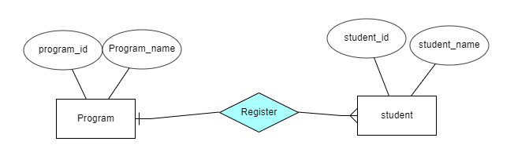

1. A program can be registered by at most one student and a student can register almost one program
2. A program can be registered by at most 1 student and a student can register for N programs
3. A program can be registered by N students and a student can register at most 1 program
4. A program can be registered by N students and student can register for N programs

Answer C

Q9. The person is using web browser “Mozilla” is on computer one; and accessing a webserver “RDBMS” is on computer two. this is an example of a(n)_______________

1. One tier architecture
2. Two tier architecture
3. Three tier architecture
4. None of mentioned

Answer b

Q10. Match the following

|  |  |
| --- | --- |
| 1. A person who develops a high-level language program that meet a functional requirement of the database is usually called: | 1. Cardinality of the relation |
| II. The number of attributes in the relation | 1. Degree of the relation |
| 1. The people who are not required understanding of the complete logical schema of the database | 1. An application Programmer |
| 1. The number of tuples in the relation | 1. Data entry operator |
|  | 1. A data analyst |
|  | 1. Database administrator |

Answer:

1. I- 4, II- 1 , III-5, IV- 2
2. I- 3, II- 1 , III-5, IV- 2
3. I- 3 , II- 2 , III-5, IV-1
4. I- 3, II- 2 , III-4, IV-1

Answer d

Q11. Which of the following insert statements are correct as per following relational schema:

customer (customerid int: Primary key, customername varchar(30),location varchar(35) not NULL)

1. INSERT INTO customer values(1, 'phagwara');
2. INSERT INTO customer(customerid, customername) values(1,'arpit');
3. INSERT INTO customer(customerid, location) values(1,'phagwara');
4. INSERT INTO customer(customerid) values(1);

Answer c

Q12. Consider the following ER diagram:

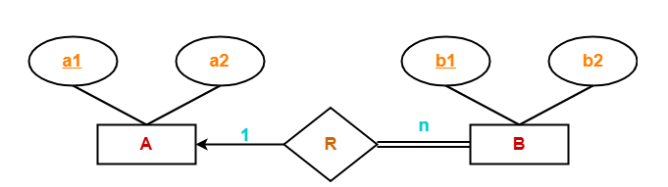

How many tables will be required?

1. 1
2. 2
3. 3
4. 4

Answer b

Q13. Drop Table employee cannot drop a table if a table’s attribute is referenced by ___________

Constraint.

1. Unique
2. Primary key
3. default
4. foreign key

Answer d

Q14. A logical structure of the database.

1. Schema
2. Instance
3. Attribute
4. Key attribute

Answer a

Q15. Identify the correct query to add a foreign key constraint on existing column in the table:

1. Alter table tablename add foreign key(colum_name);
2. Alter table tablename foreign key(column_name) references referencedtablename(primary key column)
3. Alter table tablename add foreign key(column_name) references referencedtablename(primary_key_column)
4. Alter table tablename add references referencedtablename(primary key column)